RULES: USPSA Handgun Competition Rules COURSE DESIGNER: Ike Starnes
Stage Procedure
SCORING: | Comstock, 12 rounds, 60 points
TARGETS: | 6 USPSA Targets
SCORED HITS: | Best 2 per USPSA Target
START-STOP: | Audible - Last Shot
START POSITION: | The Handgun Start Position is both feet touching the marks, wrists below belt. Handgun is loaded and holstered.  The PCC Start Position is both feet touching the marks. Carbine is loaded and held in both hands with stock touching belt.  The Make Ready position is at the same location as the Start Position.
PROCEDURE: | Upon the start signal, engage targets from within the shooting area.
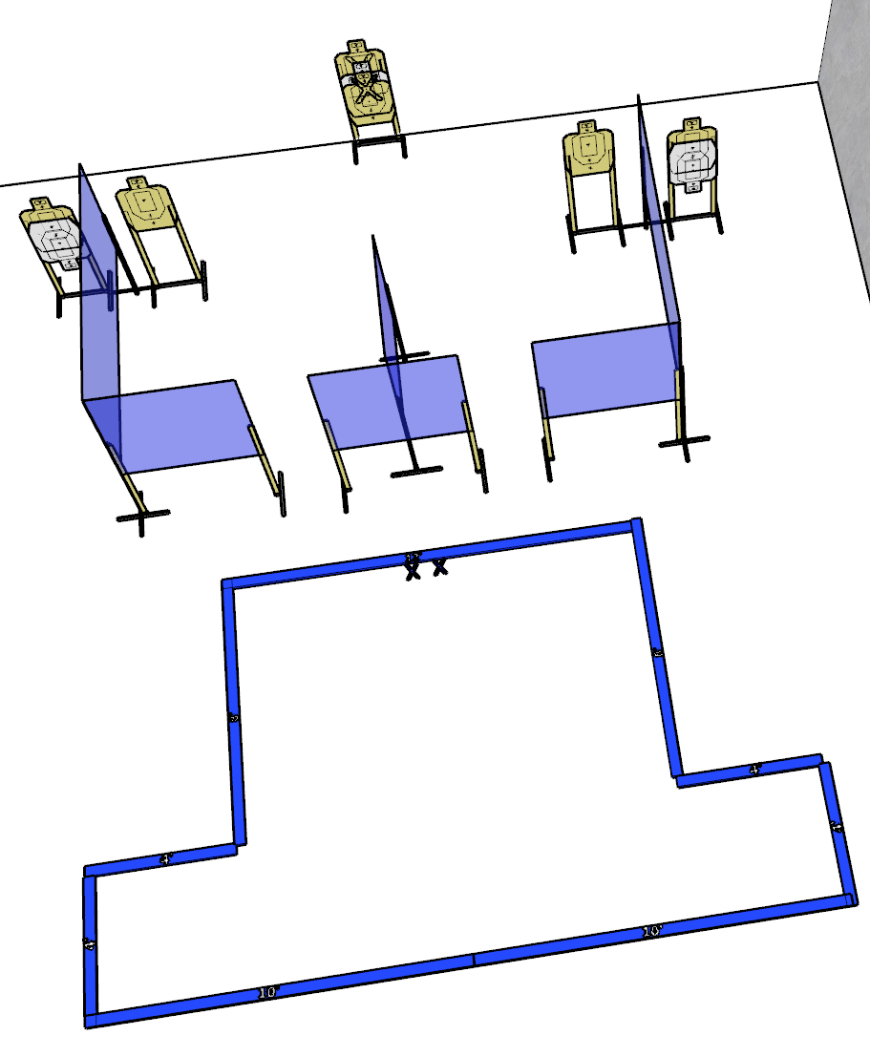

Written Stage Briefing

CM 26-XX BTSS Short Course is a 12 round, 60 point Comstock Classifier course. There are 6 USPSA targets. The best 2 hits per target will score. The start signal is audible.
The Handgun Start Position is both feet touching the marks, wrists below belt. Handgun is loaded and holstered.
The PCC Start Position is both feet touching the marks. Carbine is loaded and held in both hands with stock touching belt.
The Make Ready position is at the same location as the Start Position.
Upon the start signal, engage targets from within the shooting area.

Build Diagram
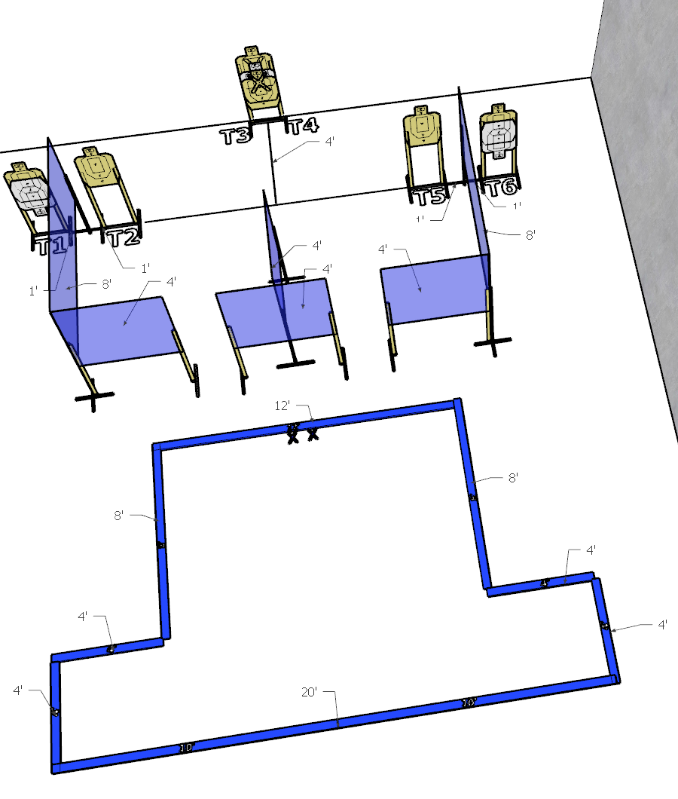
Build Instructions
Prop Inventory
Paper
USPSA Targets | Half Size USPSA | IPSC | Half Size IPSC
9
Forward Falling Steel
USPSA | USPSA Mini | IPSC | IPSC Mini | Colt
Rear Falling Steel
USPSA | USPSA Mini | IPSC | IPSC Mini | Colt
Environment Materials
8’ Wall | 4’ Wall | Wall Stands | Target Stands | Target Sticks | Fault Lines
2 | 4 | 10 | 5 | 10 | 64’
Special Props
- Start Marks

Setup Notes:
All targets are 5ft to the shoulders. Center-to-Center of the Start Marks is 18 inches. Start Marks are centered on the up-range fault line. For the center array, the top of the no-shoot is 1 overlay width below the top of the lower T1 A-zone perforation. The top of the T4 target is aligned perf to perf with the shoulder of the no-shoot.
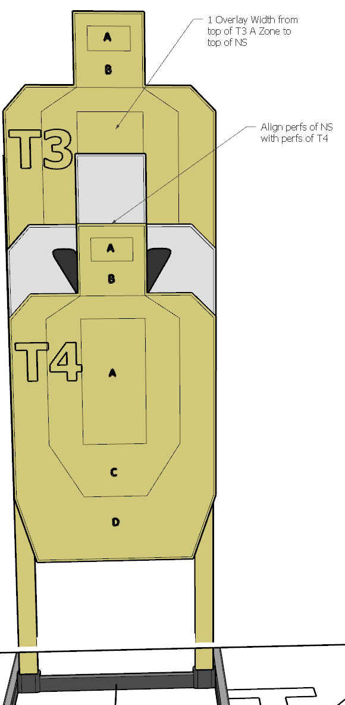
Stage Footprint:
- Width: 21 ft
- Depth: 28 ft
- Suggested Min Bay Size: 25 ft by 30 ft

Views: